GENERAL & ANALYTICAL CHEMISTRY I
CHMG-141
With Dr. Bailey Name_______________

KEY

Sample and Practice problems
Quantum Numbers and Electron Configuration,
Periodic Table Trends
(Ch. 2)

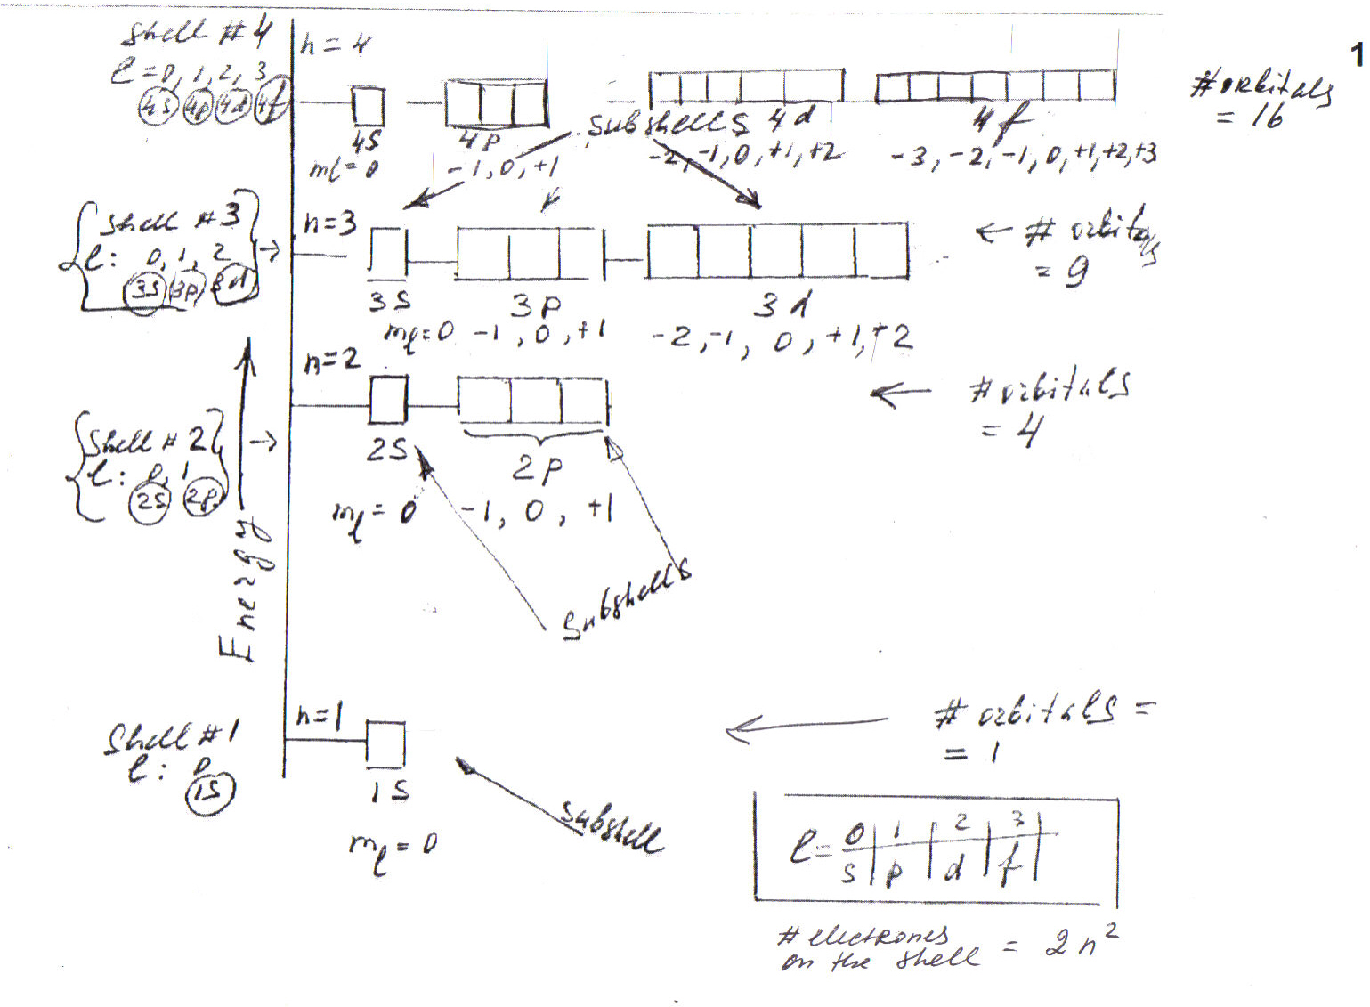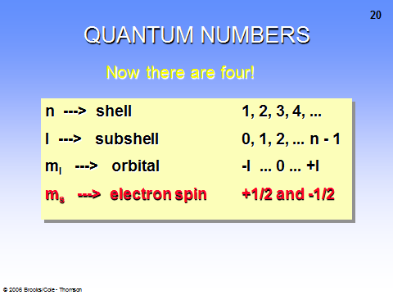

- Write the ground state electron configuration (use s,p,d,f notation) of the following elements: He, N, F, Al, Ar. Note: valence electrons!

Example: Li 1s²2s¹

  - He 1s²
  - N 1s²2s²2p³
  - F 1s²2s²2p⁵
  - Al 1s²2s²2p⁶ 3s²3p¹
  - Ar 1s²2s²2p⁶ 3s²3p⁶
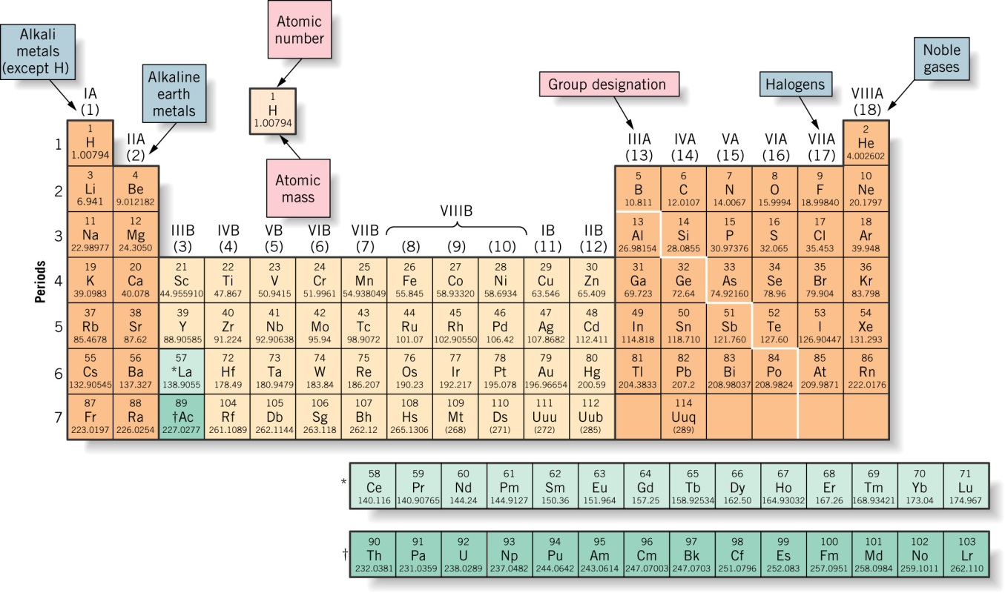

- Using the configuration of Ar as a starting point (Nobel gas notation) write the ground state electron configuration of the following elements Ti, Cr, Mn, Fe, Cu

  - Ti [Ar] 4s²3d²
  - Cr [Ar] 4s¹3d⁵
  - Mn [Ar] 4s²3d⁵
  - Fe [Ar] 4s²3d⁶
  - Cu [Ar] 4s¹3d¹⁰

- Do an energy level diagram for N, Ar.
Example Carbon 1s²2s²2p²

Carbon 1s²2s²2p²
2p _↑ _ _↑__ ___ Hund’s Rule!
2s _↑ ↓_
1s _↑ ↓_

N 1s²2s²2p³

2p _↑ _ _↑__ _↑__ Hund’s Rule!
2s _↑ ↓_
1s _↑ ↓_

Ar 1s²2s²2p³ 3s²3p⁶
3p _↑ ↓_ _↑↓_ _↑↓_
3s _↑ ↓_
2p _↑ __ _↑__ ___
2s _↑ ↓_
1s _↑ ↓_

More examples for practice:

Do an energy level diagram for Ti, Cr, Mn, Fe starting at Ar.

Ti [Ar] 4s²3d²
3d _↑ __ _↑__ ___ ___ ___
4s _↑ ↓_

Cr [Ar] 4s¹3d⁵
3d _↑ __ _↑__ _↑__ _↑__ _↑__
4s _↑ _

Mn [ Ar] 4s²3d⁵
3d _↑ __ _↑__ _↑__ _↑__ _↑__
4s _↑ ↓_

Fe [Ar] 4s²3d⁶
3d _↑ ↓__ _↑__ _↑__ _↑__ _↑__
4s _↑ ↓_

- Using the ground state electron configuration set up a table to show the four quantum numbers for each of the: Li, F, and P.

Example: Nitrogen 1s²,2s²,2p³
n | l | m_{l} | m_{s}
1 | 0 | 0 | + ½
1 | 0 | 0 | - ½
2 | 0 | 0 | + ½
2 | 0 | 0 | - ½
2 | 1 | -1 | + ½
2 | 1 | 0 | + ½
2 | 1 | 1 | + ½

Hund’s Rule!

Li 1s²,2s¹
n | l | ml | ms
1 | 0 | 0 | + ½
1 | 0 | 0 | - ½
2 | 0 | 0 | + ½

Fluorine 1s²,2s²,2p⁵
n | l | ml | ms
1 | 0 | 0 | + ½
1 | 0 | 0 | - ½
2 | 0 | 0 | + ½
2 | 0 | 0 | - ½
2 | 1 | -1 | + ½
2 | 1 | 0 | + ½
2 | 1 | 1 | + ½
2 | 1 | -1 | - ½
2 | 1 | 0 | - ½

Phosphorus 1s²2s²2p⁶ 3s²3p³
n | l | ml | ms
1 | 0 | 0 | + ½
1 | 0 | 0 | - ½
2 | 0 | 0 | + ½
2 | 0 | 0 | - ½
2 | 1 | -1 | + ½
2 | 1 | 0 | + ½
2 | 1 | 1 | + ½
2 | 1 | -1 | - ½
2 | 1 | 0 | - ½
2 | 1 | 1 | - ½
3 | 0 | 0 | + ½
3 | 0 | 0 | - ½
3 | 1 | -1 | + ½
3 | 1 | 0 | + ½
3 | 1 | 1 | + ½

- Express the four quantum numbers for the valence electrons of Be, O, Na, Si.

 | valence electrons | n | l | m_{l} | m_{s}
Be | 2s² | 2 | 0 | 0 | +1/2
 |  | 2 | 0 | 0 | -1/2
Na | 3s¹ | 3 | 0 | 0 | +1/2
Si | 3s²3p² | 3 | 0 | 0 | +1/2
 |  | 3 | 0 | 0 | -1/2
 |  | 3 | 1 | -1 | +1/2
 |  | 3 | 1 | 0 | +1/2
Hund’s Rule!

 | Valence electrons | n | l | m_{l} | m_{s}
Oxigen | 2s²2p⁴ | 2 | 0 | 0 | +1/2
 |  | 2 | 0 | 0 | -1/2
 |  | 2 | 1 | -1 | +1/2
 |  | 2 | 1 | 0 | +1/2
 |  | 2 | 1 | +1 | +1/2
 |  | 2 | 1 | -1 | -1/2

- Write an acceptable set of the first three quantum numbers for the following electron configurations.

configurations | n | l | m_{l}
4d² | 4 | 2 | -2, +2
1s¹ | 1 | 0 | 0
3d⁴ | 3 | 2 | -2, -1, 0, +1
2d³ | Doesn’t exist
4p¹ | 4 | 1 | -1
3p² | 3 | 1 | -1, 0

- Periodic Table Trends:
- Size of the atoms
- Ionization energy
- Affinity

- What is the trend in size of the atoms as you go from left to right along Period 2?
Give at least on explanation for this trend.

As you go across from left to right in a row the atomic radius gets smaller. This is due to the increase in the effective nuclear charge that is occurring on the same energy level. The principal quantum number remains the same as you go across the period.

- What is the trend in size of the atoms as you go from top to bottom in Group IIA?
Give at least on explanation for this trend.

As you go down from top to bottom in a Group of Family the atomic radius increases because there are more ‘layers’ of energy levels. The principal quantum number increases as you go down a column. The effective nuclear charge Z* remains relatively constant.

- What is the trend in ionization energy of the atoms as you go from left to right along Period 2?
Give at least on explanation for this trend.

As you go across from left to right in row 1st ionization energy increases. This is due to the increase in the effective nuclear charge that is occurring on the same energy level or principal quantum number. The size of the atom is decreasing and this places the electrons ‘closer’ to the nucleus.

- What is the trend in ionization energy of the atoms as you go from top to bottom in Group IIA?
Give at least on explanation for this trend.

As you go down from top to bottom in a Group of Family the 1st ionization energy decreases because there are more ‘layers’ of energy levels. The extra ‘layers’ of electrons produces a shielding effect that lowers the pulling power of the nucleus thus producing a smaller effective nuclear charge. The effective nuclear charge Z* remains relatively constant.

Optional, if you are interested:

Electronic Configuration | Ionization Energy [IE] | What is Happening | Why
s¹ to s² | Increases | Filling s orbital | It takes more energy to remove the electron that fills the s orbital
s² to p¹ | Decreases | Starting a new subshell with a new orbital. | p¹ electron has more energy than s²; takes more external energy to remove p¹. This change in IE evidence for existence of p subshell. The s electrons shield the p electrons.
p¹ to p² to p³ | Increases | ½ filling each orbital in p subshell. | There is an increasingly stronger nuclear charge.
p³ to p⁴ | Decreases | 1st p orbital is now filled | The paired p electrons repel each other; takes less external energy to remove p⁴.
p^{4 to} p⁵ to p⁶ | Increases | Completely filling p subshell and all of the orbitals. | There is an increasingly stronger nuclear charge

